老师说是研究物理层的？

为什么要将AI引入通信

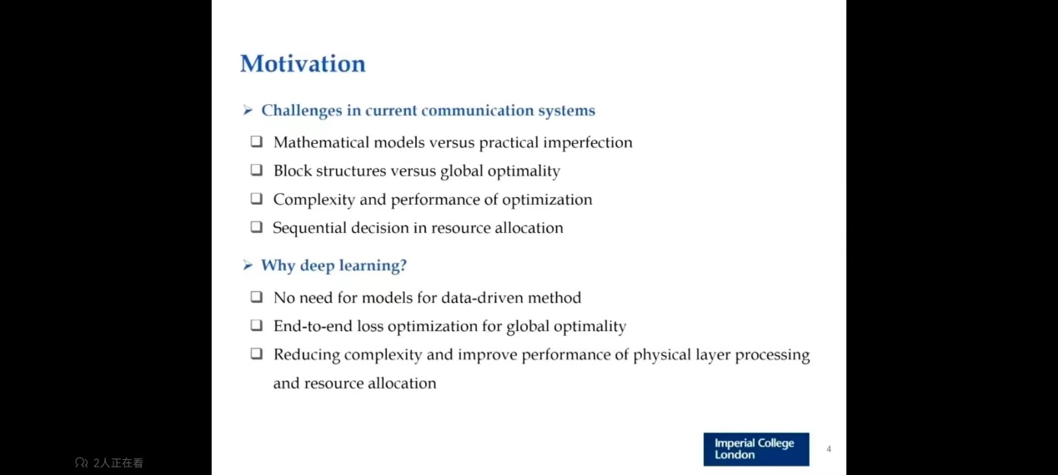

**Deep Learning Enabled Semantic Communication Systems**

我不理解这个jointly到底是什么意思

如何去辨别语句的相似度？ Sentence similarity

最近十篇文章：

**1.Deep Learning-Based Channel Estimation for Massive MIMO With Hybrid Transceivers**

In this paper, we propose a novel deep learning (DL) based framework for uplink channel estimation in HAD massive MIMO systems

Massive MIMO, channel estimation, hybrid analog-digital, angular space segmentation, deep learning.

**2.Learn to Adapt to New Environment from Past  
Experience and Few Pilot**

In this paper, we will significantly reduce the required amount of training data  
for new environments by leveraging the learning experience  
from the known environments

Therefore, we introduce few-shot  
learning to enable the communication model to generalize to new  
environments, which is realized by an attention-based method

Channel estimation, deep learning, few-shot  
learning, power delay profile, attention mechanism.

**3.LEO Satellite-Enabled Grant-Free Random Access  
with MIMO-OTFS**

his paper investigates joint channel estimation and  
device activity detection in the LEO satellite-enabled grant-free  
random access systems with large differential delay and Doppler  
shift.

Random access, OTFS, satellite communica-  
tions, message passing, Doppler shift

**4.Hybrid Precoding for Mixture Use of Phase Shifters and Switches in mmWave Massive MIMO**

To reduce the hardware complexity introduced by the large number of switches, we  
consider a group-connected VPS architecture and propose a HPD scheme, where the HPD problem  
is divided into multiple independent subproblems with each subproblem flexibly solved by the VPS-  
HPD or VPS-LC-HPD scheme.

Alternating minimization, hybrid precoding, millimeter wave (mmWave) communications, phase  
shifters, switches

**5.Overview of Deep Learning-based CSI Feedback in Massive MIMO Systems**

. In this paper, a comprehensive overview of state-of-the-art research on this topic is provided, beginning with basic DL concepts widely used in CSI feedback and then categorizing and describing some existing DL-based feedback works. The focus is on novel neural network architectures and utilization of communication expert knowledge to improve CSI feedback accuracy.

Index Terms—CSI feedback, massive MIMO, deep learning,  
overview

**6.0/1 Deep Neural Networks via Block Coordinate Descent**

# 7.Robust Semantic Communications with Masked VQ-VAE Enabled Codebook

# 8.QoE-Aware Resource Allocation for Semantic Communication Networks

# 9.Joint Optimization of Transmission and Computation Resources for Satellite and High Altitude Platform Assisted Edge Computing

**10 也是语义通信**

**Deep Learning-based Channel Estimation for Beamspace mmWave Massive MIMO Systems. 引用441**

通过深度学习网络来解决信道估计问题（the characteristic is highly similar to a 2D natural image）

**Deep Reinforcement Learning based Resource Allocation for V2V Communications. 引用367**